**Pamela’s Diner’s Website Development Design Guide**

**Logo**

**Colors**

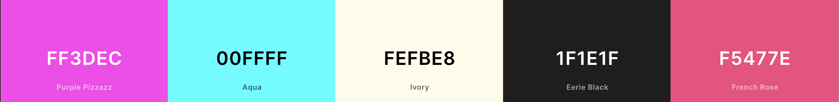

**Fonts**

Roboto, sans-serif

Title

Subtitle

Heading 1

## Heading 2

### Heading 3

#### Heading 4

Body Text

**How My Design Is Intended For Visitors Navigating The Site For The First Time**

In my design, I have a navigation bar fixed on the top of the website, which links to the home page, online order page, menu page, locations and hours page, what’s everyone saying page, and a contact page. Users can click on the links or use the “tabs” and “enter” keyboards to access subpages. The color of the link to the current page is in stark contrast to links to other pages. Whenever users’ cursor is at an area where my link is located, if it is a graphical link, it will change the opacity to signal users that it is clickable; if it is a text link, it will be underlined. I also include many buttons, such as online order buttons and a submit button, which will change colors if the cursor is located on them, signaling users that these buttons are clickable. In addition, I included a tab for users to read reviews easily, which can be used simply by hovering the cursor on it.

Information Architecture Approach

Every page has a navigation bar that links to six different pages for my information architecture: Home, Order Online, Menu, Locations&Hours, What’s Everyone Saying, and Contact, and has a footer that presents links to social media: YouTube, Facebook, Yelp, and Instagram. Below these links, I include the copyright and contact information of phone number, email address, and physical location address. Every page also has its specific content part. On the home page, the content part is two paragraphs of text explaining basic information about Pamela. There is a link to an article introducing Pamela’s Diner at the end. Under the Order Online page, we have three buttons linking to different locations for online ordering; this page also has 15 images as a lightbox gallery. There is a button under the menu page linking to the pdf of the menu; the website also contains an informal menu. Under the Locations&Hours page, there is a google map and a table of operation hours. Under the What’s Everyone Saying page, there is a tab for easy reading, and it shows images of reviews from Yelp, Restaurantji, and Trip Advisor. These images also link to external websites. Under the contact page, there is a table of operation hours embellished by a photo of Pittsburgh incline; this page also has a form collecting users’ Diagram
information and a submit button that can email Pamela’s Diner about the user’s information.